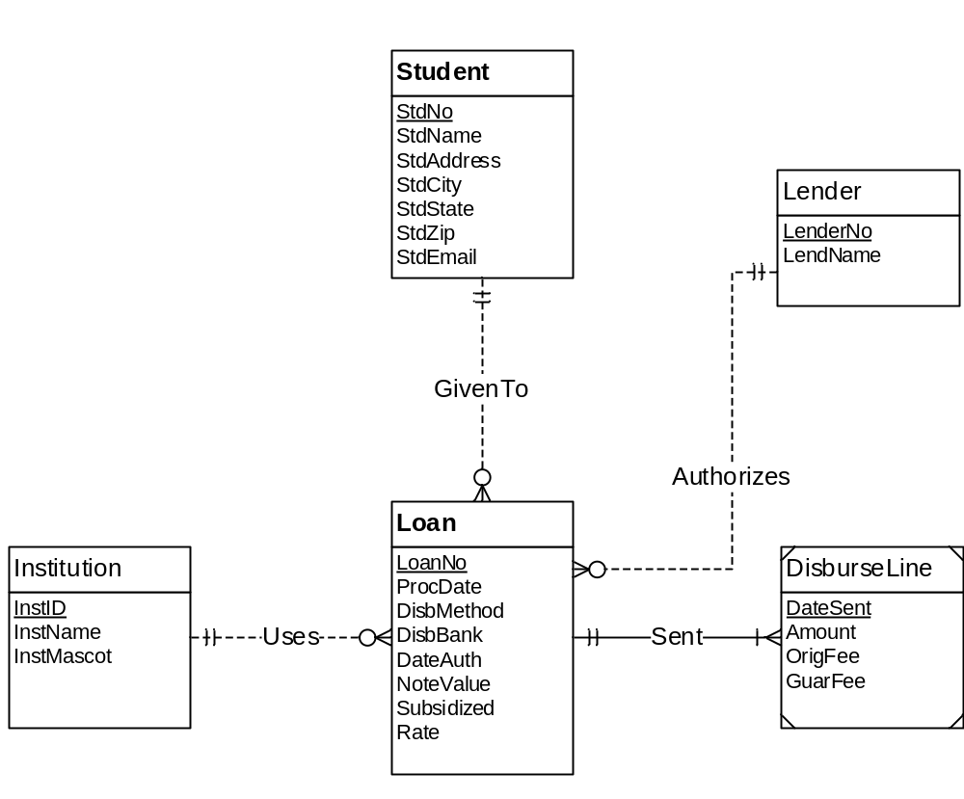
Figure 1: ERD for Problems 1 to 4
The DisburseLine table has change from Problem 2 since it is the only associative entity.
- DisburseLine ( PRIMARY KEY(DateSent,LoanNo),Amount,OrigFee,GuarFee)
FOREIGN KEY (LoanNo) REFERENCES Loan

- LoanNo also became a Primary Key when Identification Dependency conversion rule is applied. Not null constraints is not needed for LoanNo because this column is part of the primary key of DisburseLine.

